**McLaughlin 80 Sites Description**

McLaughlin 80 sites is a long-term plant community dataset for a series of 80 grassland plots at McLaughlin Reserve – Lake/Napa County, California.

**Disturbance and abiotic characteristics**

Half of the plots are on low-nutrient, low Ca:Mg ratio serpentine soils while the other half occur on a variety of other soil types – non-serpentine. All sites are on herbaceous dominated vegetation. Approximately half of the plots occurred on previously grazed sites. Grazing pressure varied and ended entirely by 2001. Various fires have burned through several sites at varying time intervals. Management or accidental human impacts have also affected a few sites.

**Design and methods**

Each site is a 40 meter transect with a 1 x 1 m quadrat sampled at ~ 10 meters (see diagram below). Since 2006 percent cover has been visually estimated for each species within the quadrat to the 0.1 % accuracy. Previous to 2006 diversity data is presence/absence only. An additional 20 sites is included in some files for abiotic data, but the core sites are numbered 1-80. Quads are numbered 1-5. Sites are permanently marked with rebar at each end and tagged at quad #1, however, a few plots are read “backwards”, or with the tag side as quadrat 5. The layout is to place the first quadrat with the middle (50 cm point) of the 1 x 1 PVC quadrat at the quad 1 marker in-line with the other four quadrat markers. The next 3 quadrats are read towards the end of the transect, but the final quadrat - #5 – is oriented back towards the other 4 quadrats to keep all 5 quadrats within the 40 m transect.

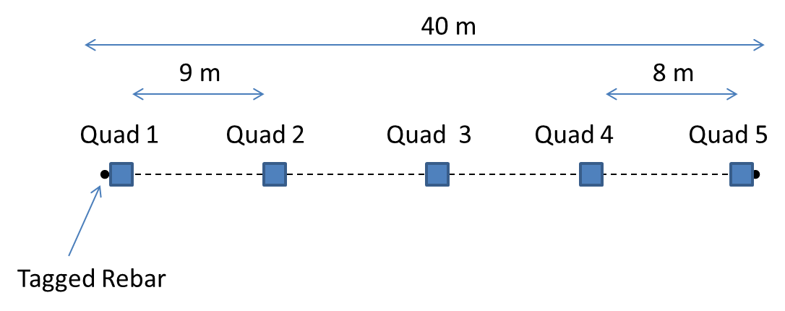

Each site is read twice a season – once at approximate peak phenology in spring (early - mid April) and once in early summer (June) – in order to capture early annuals (the bulk of the species diversity) and cover for late annuals (mostly tarweeds and grasses). The data from the two seasons is bulked to come up with cover estimates for quad by site by year.

**Associated Publications**

Elmendorf, S. C., and S. P. Harrison. 2009. Temporal variability and nestedness in California grassland species composition. Ecology **90**:1492-1497.

Elmendorf, S. C., and S. P. Harrison. 2011. Is plant community richness regulated over time? Contrasting results from experiments and long-term observations. Ecology **92**:602-609.

Fernandez-Going, B. M., B. L. Anacker, and S. P. Harrison. 2012. Temporal variability in California grasslands: Soil type and species functional traits mediate response to precipitation. Ecology **93**:2104-2114.

Harrison, S. 1999. Native and alien species diversity at the local and regional scales in a grazed California grassland. Oecologia **121**:99-106.

Harrison, S., B. D. Inouye, and H. D. Safford. 2003. Ecological heterogeneity in the effects of grazing and fire on grassland diversity. Conservation Biology **17**:837-845.